1.What is macro? Create a macro to store product detail.

Ans

A macro is an automated input sequence that imitates keystrokes or mouse actions. A macro is typically used to replace a repetitive series of keyboard and mouse actions and used often in spreadsheets and word processing applications like MS Excel and MS Word.

The file extension of a macro is commonly .MAC.

The concept of macros is also well-known among MMORPG gamers (Massively Multiplayer Online Role-Playing Games) and SEO (Search Engine Optimization) specialists. In the world of programming, macros are programming scripts used by developers to re-use code.

The term macro stands for “macro-instruction” (long instruction).

* Open the **Developer** tab and choose **Record Macro**. Add a name and shortcut for macro. In the drop-down, choose **This Workbook** > **OK**.
* Once created, perform formatting commands for the new macro, then choose **Stop Recording**> **File** > **Save As**. Save as an **.xlsm** file.
* The**Developer** tab isn't visible by default. To enable, open **Options** (PC) or **Preferences** (Mac). Open Ribbon settings, select **Developer**.

2.Explain Excel formatting.

Ans

Formatting in Excel means a trick that we can use to modify the data's appearance in a worksheet. We can format the data in various ways, like we can format the font of the cells or the table with the help of the styles and **format tab** present in the **Home tab.**

It's easier than ever to format worksheet (or sheet) data in Excel. There are various quick and easy ways to generate professional-looking worksheets that efficiently present our data. For example, we can utilize document themes to give our Excel spreadsheets a consistent design, style to apply predetermined formats, and other manual formatting capabilities to highlight essential data.

Microsoft Excel has several features that permit users to customize the way their data is displayed. And there is a solid reason for it: formatting cells can help bring attention to essential data or show the content more properly (such as adding $ to cells which comprise price values or configure cells that represent dates to a standard display of **xx/xx/xxxx).**

Excel formatting is an optional step following data preparation, or all of the **data cleansing, structuring, enriching,** and **standardizing** necessary to prepare the data for analysis.

New data rarely comes without its own unique set of issues; it is up to the analysts to analyze their data and guarantee that it is ready to meet the exact requirements of their analytical project. Splitting columns, eliminating rows with incomplete data, and standardizing against a certain name.

Once completed, Excel formatting adds the finishing touches, ensuring that the data is properly prepared and presented.

Good formatting will improve our data in various ways:

* With the help of the formatting, we can present our data correctly; for example, formatting as **dates** or **currency** will provide more value to our data.
* Merging and aligning our data is a vital aspect of making our data more readable.
* Formatting our text by **increasing the Size, bolding, adding italics,** or **changing the fonts** will improve the overall appearance of our worksheet.
* Using styles **(like table styles)** can make our data stand out and helps the reader to focus on crucial portions of the worksheet.
* **Conditional formatting** is a useful tool for highlighting crucial portions of our worksheet graphically or visibly. These are dynamic tools. The Highlighted region changes as our data changes.

3.Perform data analysis using Excel. List various functions available to perform data analysis in excel.

And

4. List down excel functions and their examples.

Ans

**Ten Essential Excel Functions for Data Analysts**

You don’t need Python for every data task

Although Python is the dominant tool in the field of data science, Excel is a handy and accessible way to perform analysis or display information to stakeholders. Since Microsoft Excel is widespread in the business world, and the interface is familiar to many without a data background, it is very useful for analysis and reports that need to be shared with other departments in your business.

In this article, we will explore ten Excel functions to get even more power out of the software and perform common data analyst tasks quickly in Excel.

**COUNTBLANK**

Raw data can be messy, and sometimes it can include missing values, especially when this data is collected in the real world. In Python, we can use a method such as isna() to detect missing values. However, this is also possible with Excel using the COUNTBLANK function.

COUNTBLANK will count the number of blank cells in a given range.

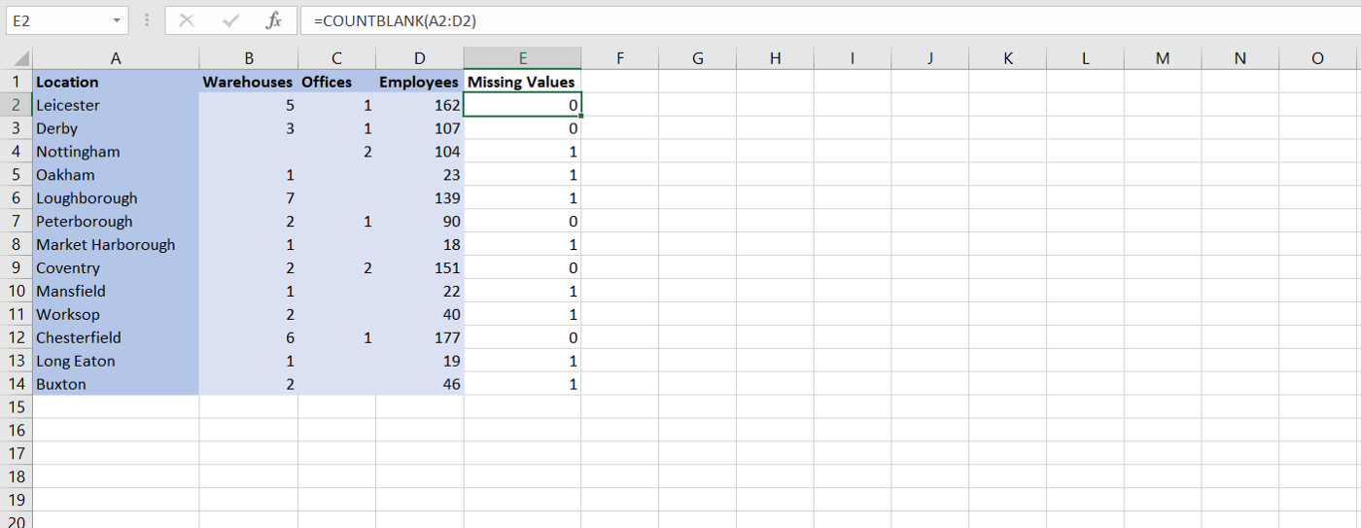

Using the COUNTBLANK function to check for missing values. Image by author.

The formula for this Excel function is:

*=COUNTBLANK(range)*

**SUMIFS**

One of the best-known and most basic Excel functions is the SUM function. Sometimes we may want to use SUM, but also exclude cells from our summation using a criterion. This is where SUMIFS comes in.

SUMIFS allows us to sum values in a given range, but only sums the values that match given criteria. As many criteria can be given to this function as desired.

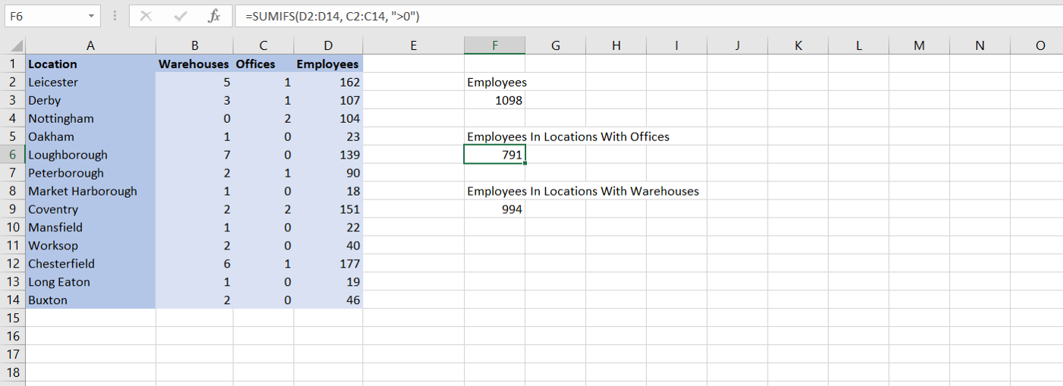

Using the SUMIFS function to count employees in different locations. Image by author.

The formula for this Excel function is:

*=SUMIFS(sum_range, criteria_range1, criteria1, …)*

**RANK**

The RANK function can be used to return the rank of a numerical value when compared to a list of other numerical values. Ranking can be very important in data analysis to know where a particular value would fall in an ordered array. There also exists a similar function known as PERCENTRANK which returns the ranking as a percentage of the dataset’s range.

It is important to note that if a value cannot be found in the given list or array, Excel will return a #N/A error. This is not true for PERCENTRANK.

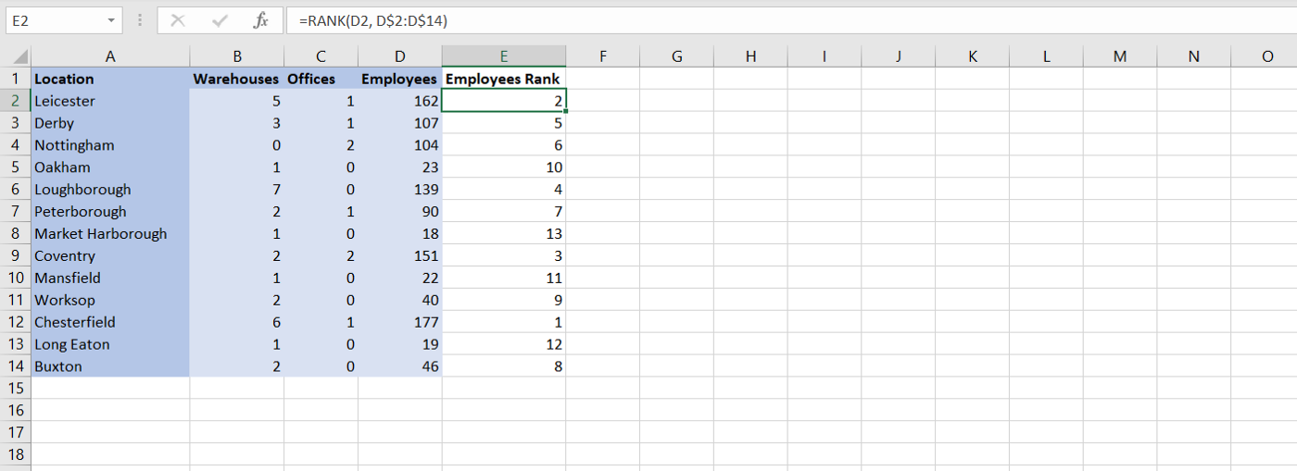

Using the RANK function to rank locations by the number of employees. Image by author.

The formula for this Excel function is:

*=RANK(number, list)*

**VLOOKUP**

VLOOKUP is one of the most important functions for any data analyst to know. It can be used to retrieve, or look up, data in a table that is organised vertically. This is incredibly useful as it can be used to automatically find data in another spreadsheet, as long as each row has an ID.

The ID column for the table must be the first column. The third parameter in the VLOOKUP function can then be used to refer to the column containing the data that you want to retrieve. It is important to note that this parameter is 1-based in Excel. This means that a value of 2 will get the 2nd column, and a value of 3 will get the third column, and so on. This is different to list indexing in Python, which is 0-based.

The other two parameters in the VLOOKUP function refer to the lookup value (or the ID of the row you are retrieving) and the range of the table itself.

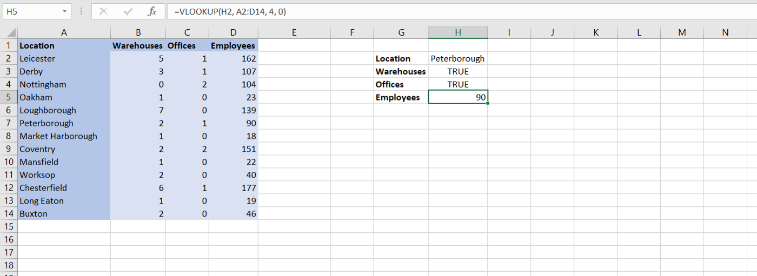

Using the VLOOKUP function to find data on different locations. Image by author.

The formula for this Excel function is:

*=VLOOKUP(lookup_value, table_array, col_index_number)*

**IFERROR**

If you are presenting your Excel spreadsheets to other people in your business, then it can be useful to have default values in cells when errors occur in your functions. This can be particularly useful when other users do not understand the meaning of errors, or the value of the cell would be known if an error occurred in calculations (such as defaulting to 0).

The IFERROR function can do exactly that. This function simply takes two parameters, the first is the function, and the second is the default value if the function throws an error. If the function does not throw an error, then the value will be outputted as normal.

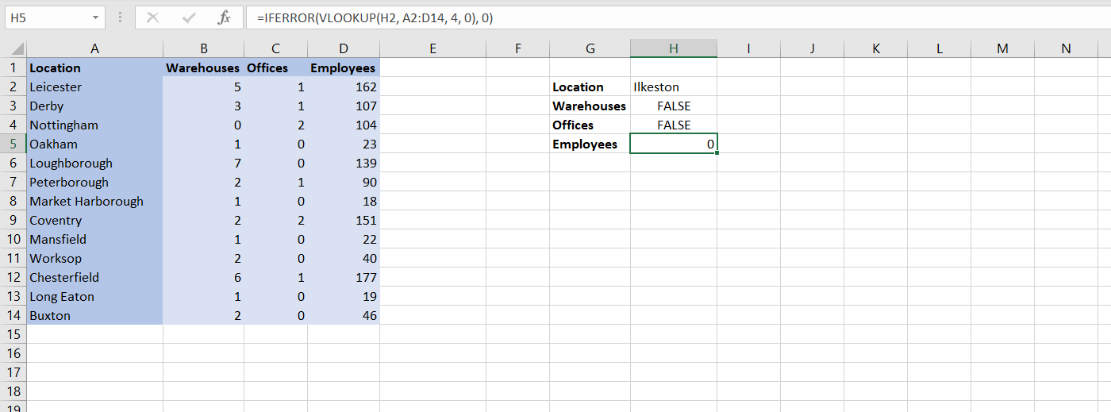

Using the IFERROR function to handle Excel errors. Image by author.

The formula for this Excel function is:

*=IFERROR(value, value_if_error)*

**DAYS**

If you have ever worked with data involving time, you will know that there are several key calculations that will keep reoccurring in your work. One of these is calculating the number of days between two dates. In Excel, we can do this with the DAYS functions.

The DAYS function takes two dates as parameters and returns the number of days between them as an integer.

One scenario where this function would be useful is calculating the time between when a product is ordered, and when that product is delivered. This is an important metric for businesses that sell products, and so it is great that Excel provides an easy way to calculate it.

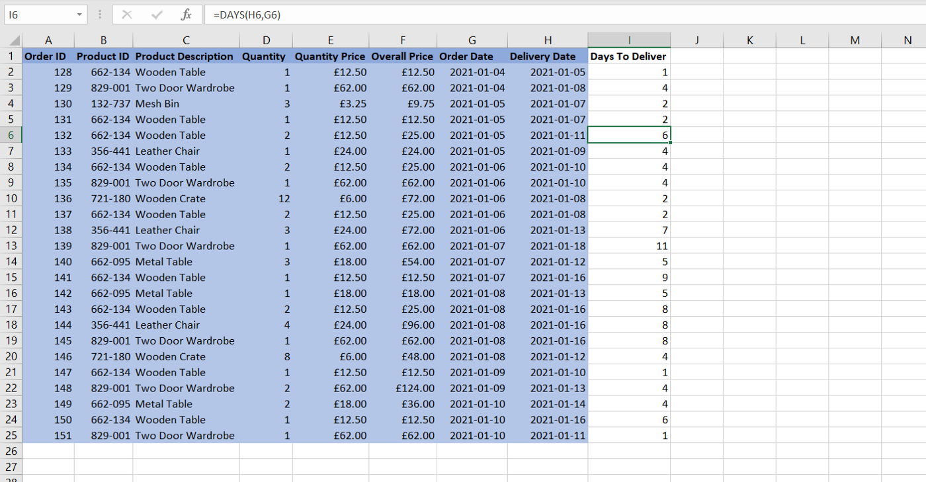

Using the DAYS function to calculate days to deliver a product. Image by author.

The formula for this Excel function is:

*=DAYS(end_date, start_date)*

**MAXIFS**

Finding the maximum value that a variable can take is extremely important in business. From knowing the busiest day of the year to the maximum amount of profit a business made in a day — there are many reasons to calculate the maximum.

Sometimes, you might only want to calculate the maximum on a subset of your data. In that case, you can use the MAXIFS function to put constraints on the data that you want to take the maximum of.

In the example below, we use MAXIFS to find the maximum days to deliver each product. The constraint is placed on the product in each row of our dataset.

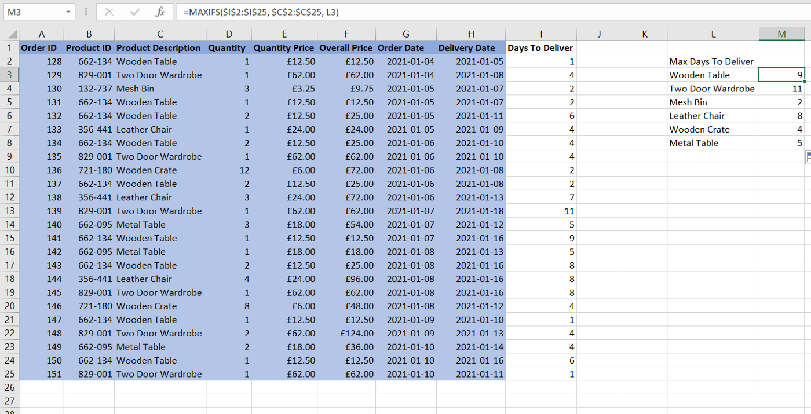

Using the MAXIFS function to get maximum delivery times for each product. Image by author.

The formula for this Excel function is:

*=MAXIFS(max_range, criteria_range_1, criteria_1, …)*

**AVERAGEIFS**

Earlier we explored the use of SUMIFS to get filtered sums of our data. We have also looked at MAXIFS to do the same but with the maximum values. By now you may have worked out that there are many different IF functions that can be used in Excel.

Some other useful IF functions include COUNTIFS, MINIFS, and the plain-old IF function. One function that does appear often is the AVERAGEIFS function, which is used to calculate averages.

In the example below, we use the AVERAGEIFS function to calculate the average delivery time for each product.

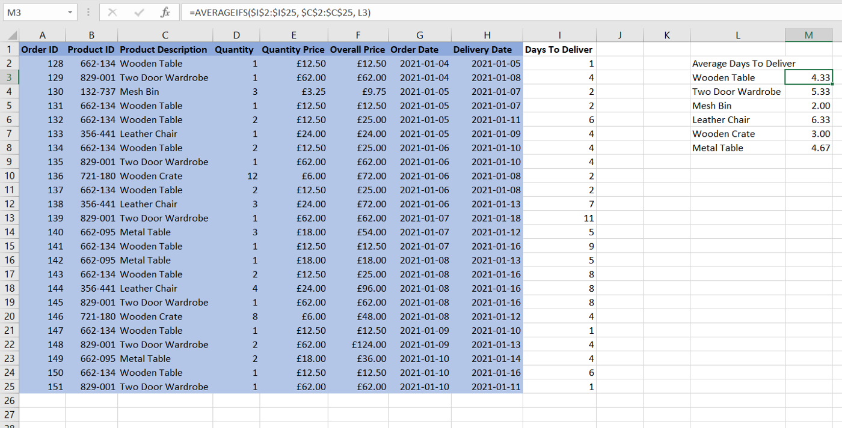

Using the AVERAGEIFS function to get average delivery times for each product. Image by author.

The formula for this Excel function is:

*=AVERAGEIFS(average_range, criteria_range_1, criteria_1, …)*

**MATCH**

Sometimes it can be useful to know the specific column or row that a data value occurs in. We will look at one use-case later in the article, but first, we will introduce the function that allows us to do it.

The MATCH function is used to determine the position of a value in a given array. It is important to remember that this result will be relative to the start of the array, so a result of 4 does not necessarily mean the value you were looking for is in the 4th column or row of the spreadsheet; it would be in the 4th position of the given range.

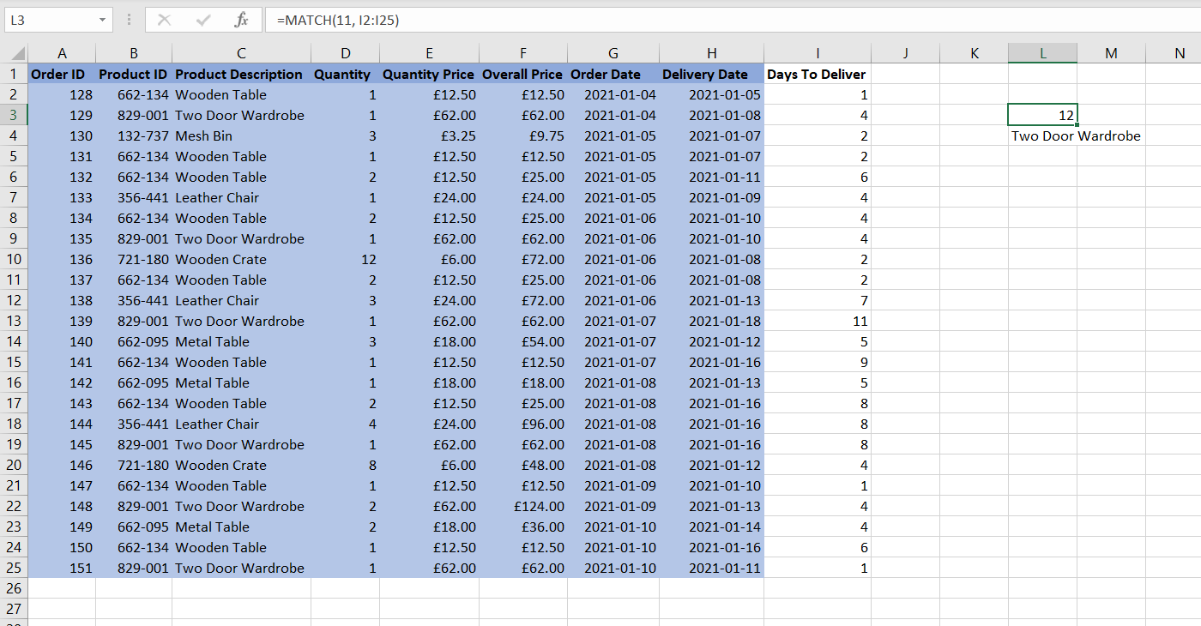

Using the MATCH function to get a specific row in the dataset. Image by author.

The formula for this Excel function is:

*=MATCH(value, array)*

**INDEX**

INDEX is a function that is commonly used with the previous MATCH function. Together, they can be used to get a value in a lookup table based upon given criteria, similar to the VLOOKUP function. However, these two functions can be used in some cases where the singular lookup functions fail, for example when the lookup value is not in the first row/column of the range.

On its own, the INDEX function is used to return the value of a cell at a given row number and index number.

In the example below, we can see that the MATCH function is used to get the row where the product is delivered in 11 days, and then the INDEX function is used to get the product description of that row.

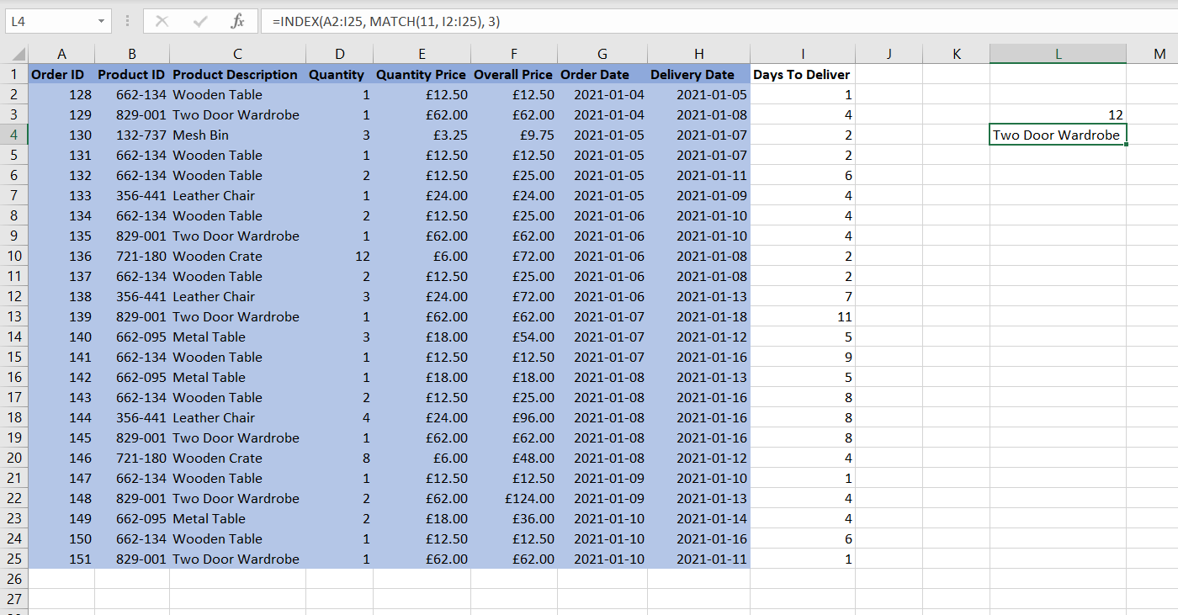

Combining the MATCH and INDEX functions for a lookup. Image by author.

The formula for this Excel function is:

*=INDEX(array, row_number, column_number)*

1. How to add annotations to a cell in Excel.

Ans

## Insert simple notes for annotation purposes

1. Right-click the cell and then click **Insert Comment** (or press Shift+F2). If you're using Excel for Office 365, right-click the cell and choose **New Note**.
2. Type your annotation text.
3. Click outside the cell.

If you need to edit the note, right-click the cell, and then click **Edit Comment**. If you're using Excel for Office 365, right-click the cell and choose **Edit Note**.

If you need to delete the note, right-click the cell and choose **Delete Comment**. If you're using Excel for Office 365, right-click the cell and choose **Delete Note**